Lab Mid
Submitted to Mam Yasmeen Jana
Submitted by Sahwana Ilyas
Registration no SP24-BSE-025
Course Web technologies
Date 09-04-2026

COMSATS University Islamabad
Vehari Campus



WhatsApp clone full demo:

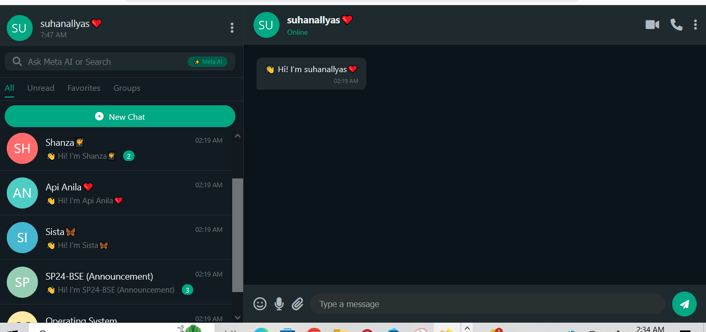
Profile menu features:
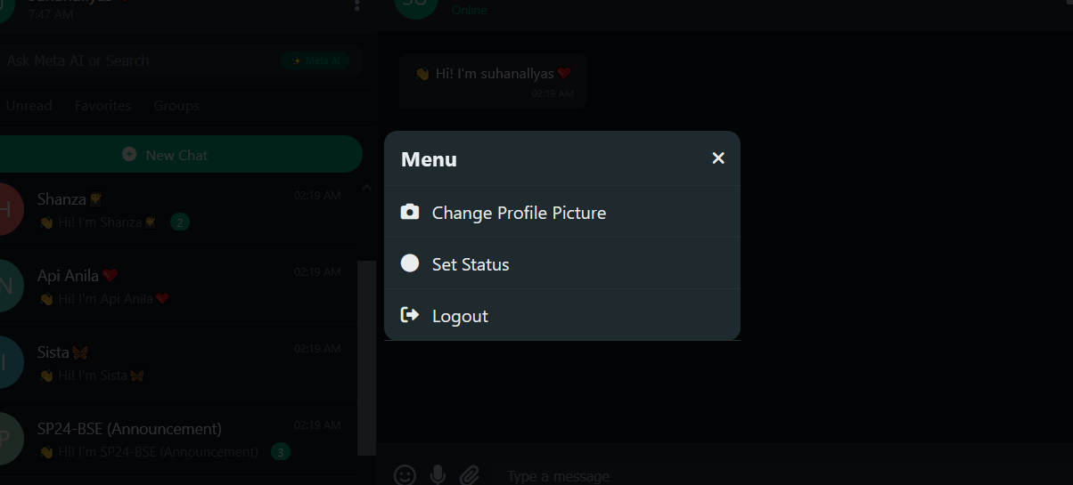

Voice and video calling feature:
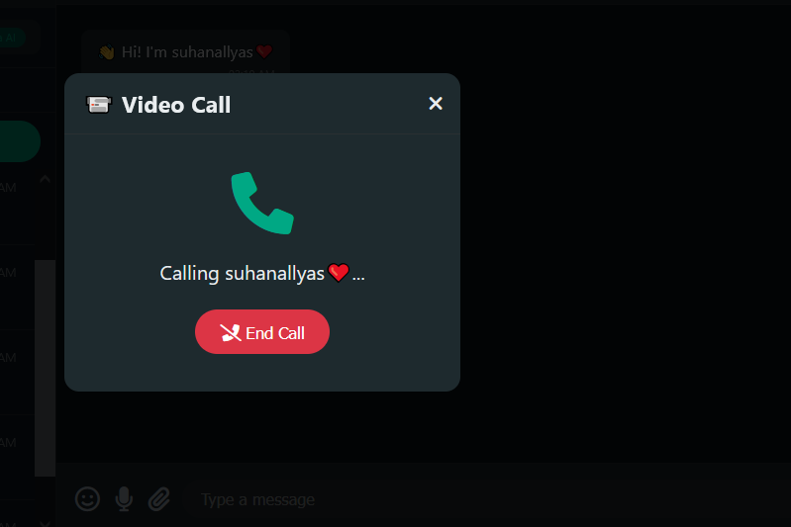
Voice note, attachments, stickers features:
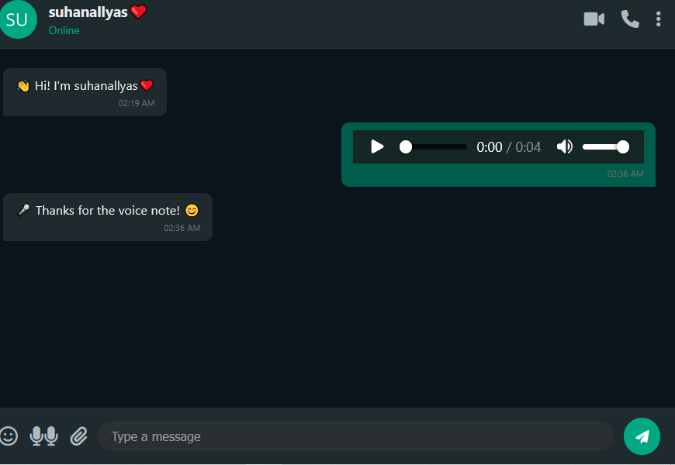

Chat:
